# CSCI 150

INTRODUCTION TO SOFTWARE ENGINEERING

SAMPLE MIDTERM EXAM (Similar to Midterm 1 of Fall 2015) October 21, 2018

Name:

This closed-book, **90** minutes exam is worth **100** points (each question is worth 20 pts except Q1 – worth 40 pts). **For each question, correctness and preciseness count. Each question is associated to your term project. If your answer does not relate to your project, you will get low score.** Choose 4 questions to answer: **Question 1 is MANDATORY.**

**Essay Answers (Suggest no more than 20 sentences for each question)**

1. [Lab Exercise] (a) Use Figure 1 to introduce a use case diagram.
2. [CH1+Term Project] (a) Maintainability, Dependability and security, Efficiency, and acceptability are five good software attributes. Please (a) choose three to explain the meaning of them and how they can be applied to your project (b) Explain why maintainability is related to software cost. (c) Explain why requirements are the most important phase in entire software process. (d) Why do you need CSCI 150? Please answer from technical perspective.
3. [CH 2+Term Project, 20pts] (a) What is moving target problem? (b) How do ALL of the following software process models address such a problem: waterfall, rapid prototyping, incremental, spiral (c) In addition to (b)’s answer, for EACH of these software process models **list** 2 advantages.
4. [Design and Testing] (a) Explain Figure 2 with *sufficient* details (b) Explain Figure 3 with *sufficient* details.
5. [Misc. + Term Project] (a) What’s the difference between centralized and distributed version control? (b) Explain Figure 4 with *sufficient* details (except “trunk” and “tag”) For example, “fetch”, “push”, “merge”, “branch”, “pull request” etc.



Fresno State would like you to computerize their registration system (portal).

1. The Registrar sets up the curriculum for a semester.
   1. One course may have multiple course sections
2. Students select 4 primary courses and 2 alternate courses
   1. Students may also declare minor.
3. Once a student registers for a semester, the billing system is notified so the student may be billed for the semester
   1. The billing system by default notifies students via emails. It also has an option to notify students via physical mails.
4. Students may use the system to add/drop courses for a period of time after registration
5. Professors use the system to receive their course section rosters
6. Users of the registration system are assigned passwords which are used at logon validation

**Figure 1**

6.



Design inputs

Design activities

Design outputs

Architectural Interface Component design design design

Database design

Component specification

Interface specification

Database specification

System architecture

Data description

Requirements specification

Platform information

**Figure 2**

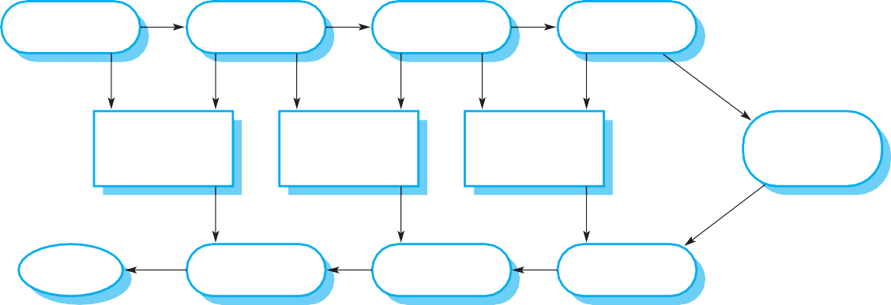

Requirements specification

System specification

System design

Detailed design

Acceptance test plan

System integration test plan

Sub-system integration test plan

Module and unit code and test

Service

Acceptance test

System integration test

Sub-system integration test

**Figure 3**

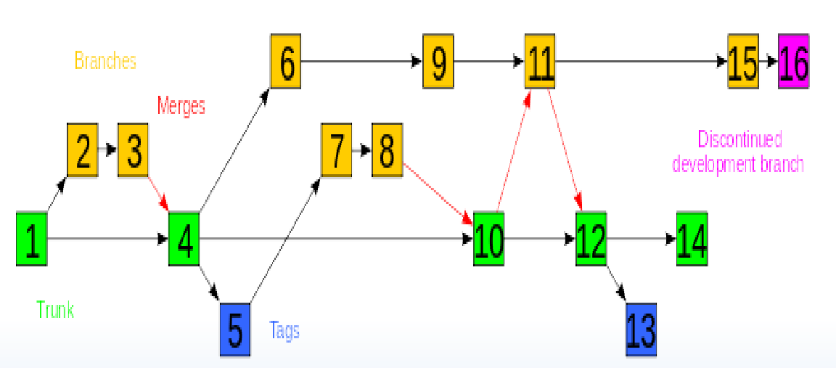

**Figure 4**

Extra questions for Chapter 3:

1. What are the manifests of agile methods?
2. List and explain 3 common features of agile methods.
3. Use Figure 3.2 (page 19 of Ch3.pdf) of textbook to compare Plan-based development and Agile development.
4. List 3 important features of XP and explain them.
5. Explain scrum with sufficient details. Please use your project as an example to explain the details.
6. Compare scrum with conventional plan-based project management. Please compare them based on effectiveness for allocating people, estimating cost, maintaining team cohesion, and managing changes.
7. Compare scrum master with project manager.